The Inner Circle Of Real Estate
“Trusted Trades people”

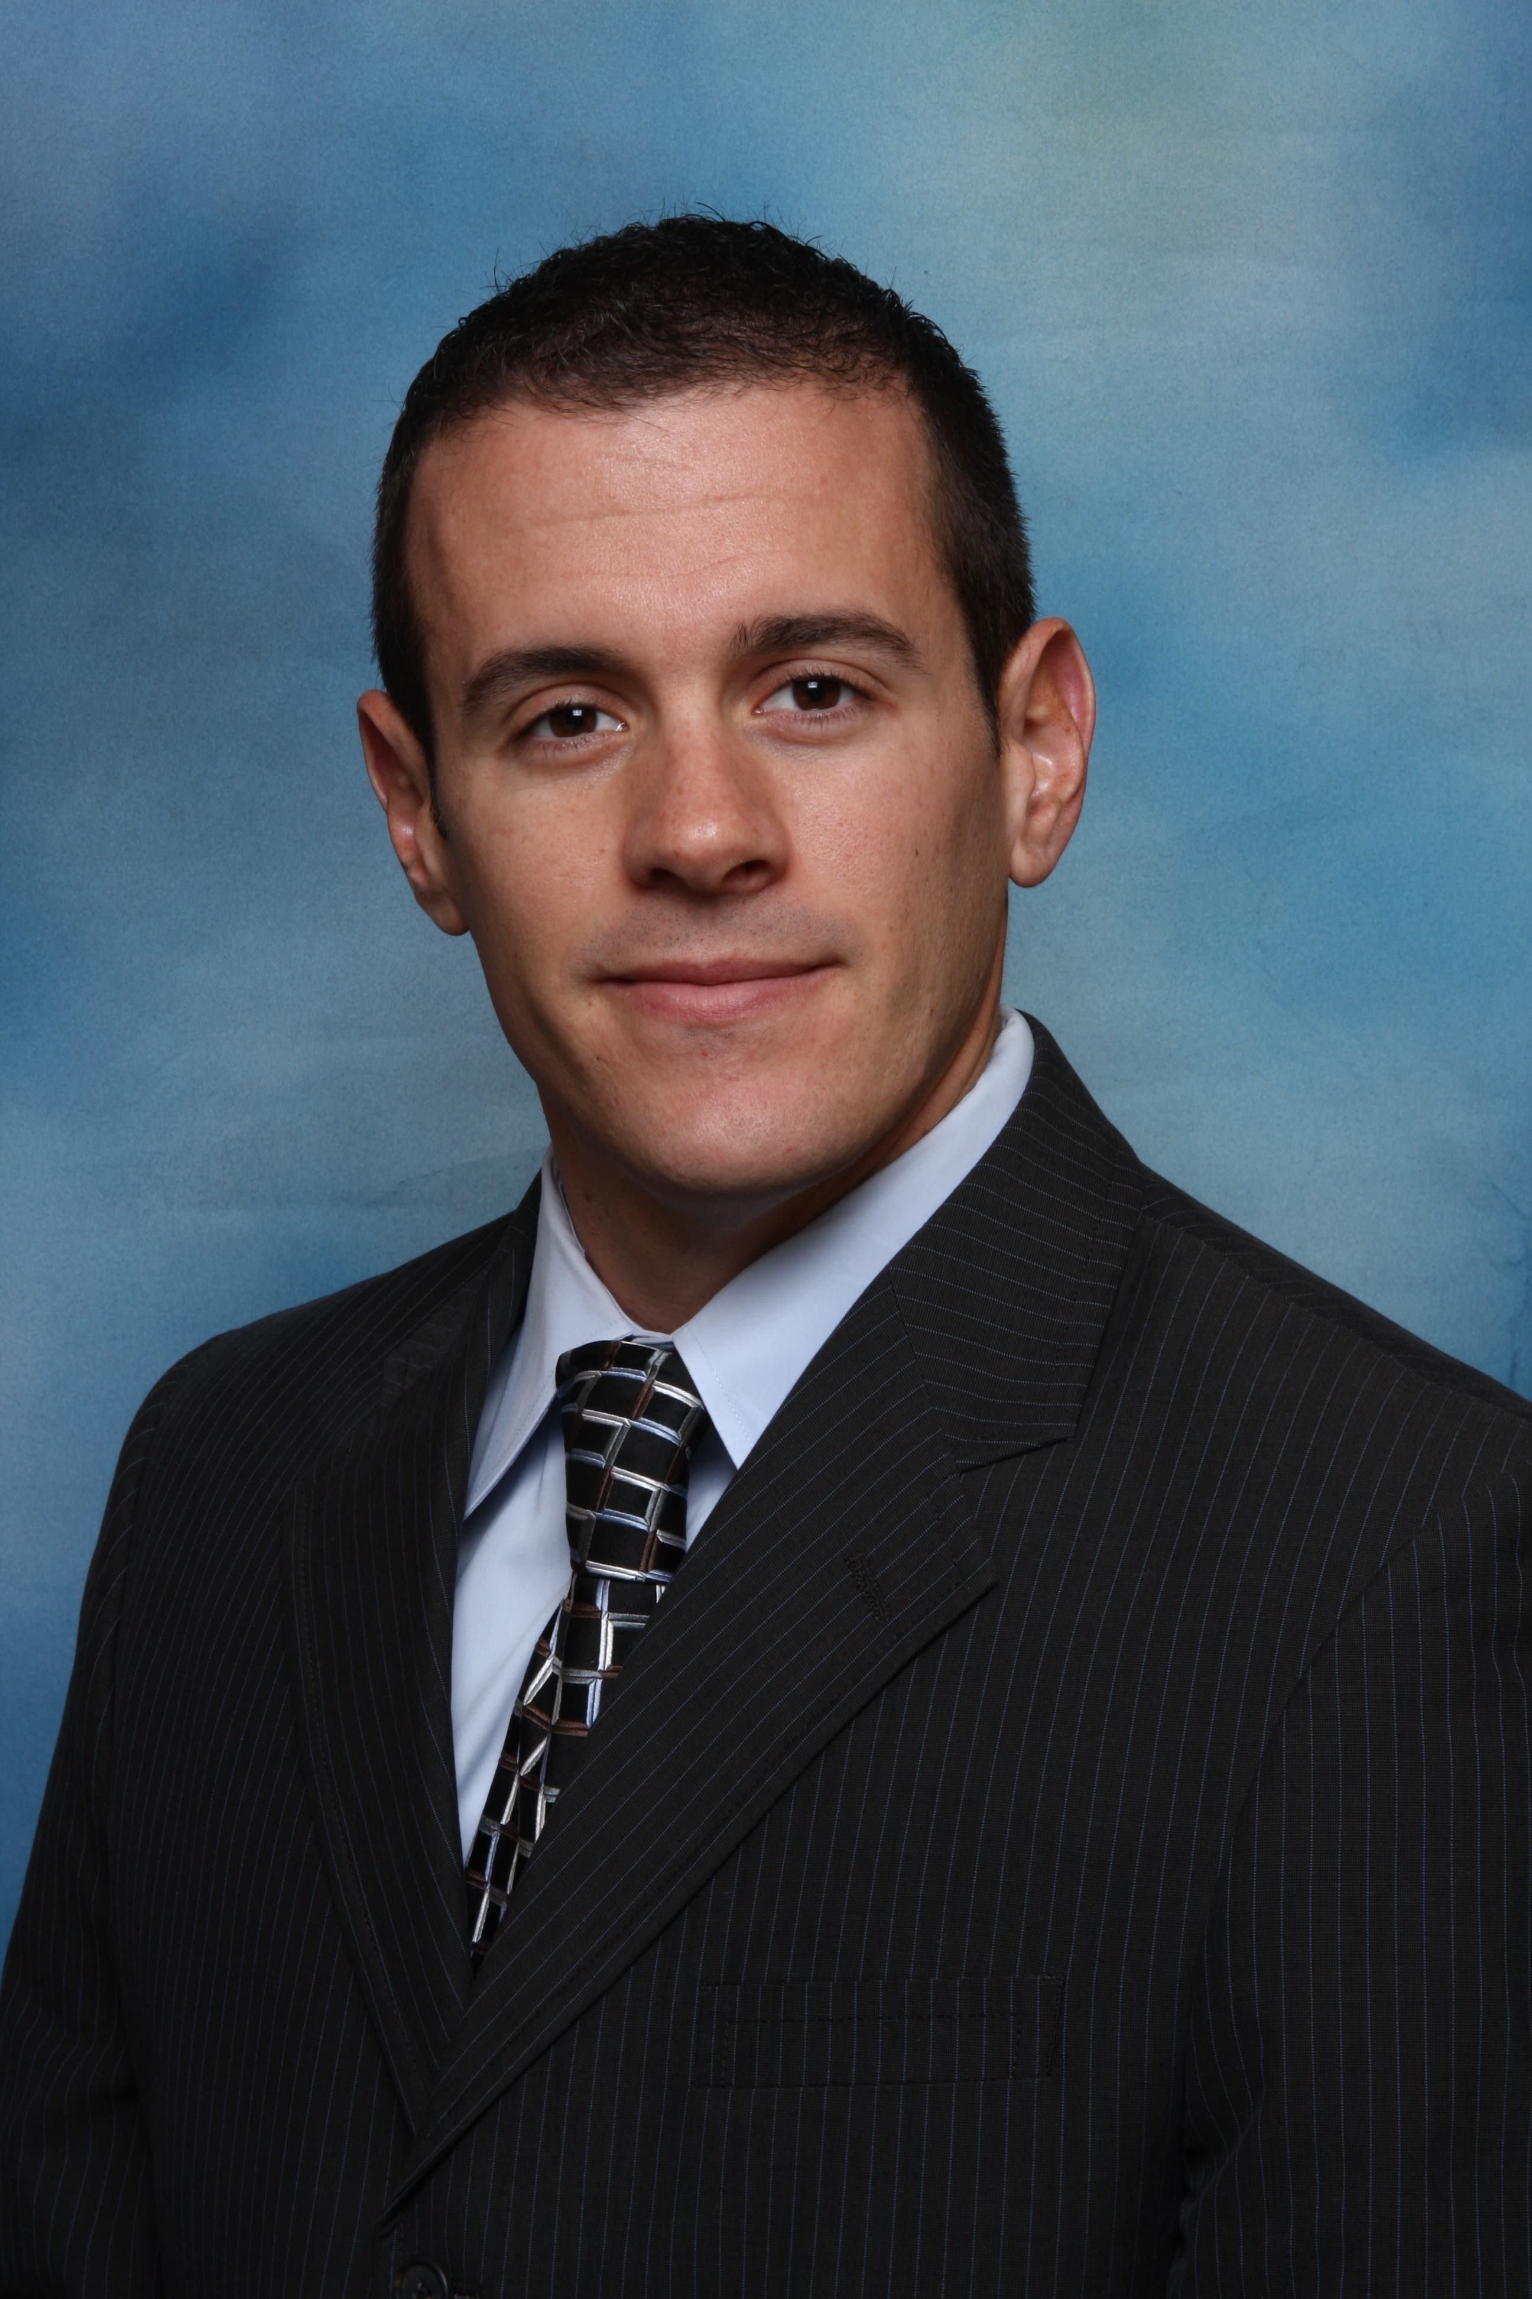
Kevin Kerins
Didonato Realtors
www.KevinKerins.com
Kevin@kevinkerins.com
609.903.8131

The Inner Circle
Experience

* Don’t forget to ask me about
Lowe’s realtor benefits!



Home Owners Insurance:
Nicole McCann- AAA Insurance
732.684.9467

Attorney:
Davis Law Practice – Mark G. Davis
301.257.5361
John E. Maziarz - 609.462.0229

Electrician:
Lombardo Electric – James Lombardo 609.947.8240
Tim Tafro – 609.240.6790

Landscaping Design:
Dreamscape Design and Build – Dennis Sheehan 609.306.6730
Joseph Kerins- - 609.709.4871

Mortgage:
The Dennis Team – Dennis J. Dennis
609.462.4011

Home Inspection:
Eastern Home Inspectors – 609.291.3100

Basements:
Carroll Construction – Michael Carroll-609.468.2451
Nick Krupa – 609.324.8055

Carpentry:
Carroll Construction – Michael Carroll - 609.468.2451
Nick Krupa - 609.324.8055
Byrne Bro Construction – 609.259.8636

Windows:
Greg Gelnaw – 732.684.2326

Below you will find a list of trades people who
I believe can be valuable resource to you! All
Are considered top professionals and are more
Than capable of providing superior quality!

Painting:
Accent Painting – Glenn Clark – 609.890.1779

Pools:
Valley Pools – Anthony Bencievengo
609.587.1772

Gutters:
Ned Stevens: 800.542.0267

Lawn Maintence:
Joseph Kerins - 609.709.4871
Outdoor Creations – 609.890.4777

Appraisals:
John McCann – 973.699.4288

Accounting:
Rich Trumper – 732.773.3127
David Carmignani – 609.890.8800

Financial Consultation:
David Carmignani and Assoc.
732.773.3127

Heating and Air Conditioning:
From Dusk till Dawn – Josh Hubiak – 732.232.8021

Plumber:
Juan Diaz – 609.709.4871

Party Planning:
Allyson Pandolfini- 609.462.4373

Title Company:
Garden State Abstract – Gina Smashey - 856.985.2922

